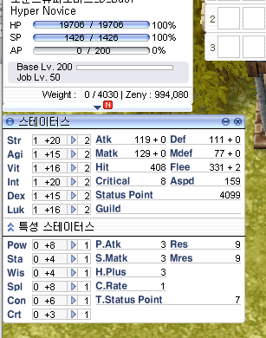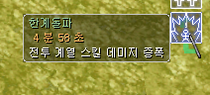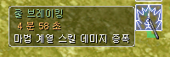

HNSK1 = 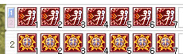

HNSk2=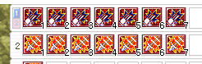

HNSk3=

HNSk4= 

HNSk5=

HNSk6=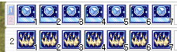

HNSk7=

HNSk8=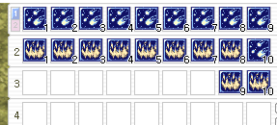

HNSk9=

HNSk10=